**1.0 INTRODUCTION**

* 1. **PROJECT SUMMARY**

Project is of online recruitment app to handle attendance, reports, results, enrolments.it saves lot of time in the recruitment process.

* 1. **PURPOSE**

The Campus campus Drive Management System is intended to replace the manual model of attendance record . The roll call and paper records are replaced with a single interaction between the professor and the Attendance Management System. Professors will be able to view details regarding attendance of individual students on their PC and quickly maintain attendance records. The system will be developed in such a way to provide easy addition of enhanced features, which may be desired in subsequent versions. This App is intended to use to reduce time wastage in college Placement during each campus drive.

* 1. **SCOPE**

The Charusat Campus Drive App will allow the teacher in charge to maintain a record of attendance of students in their respective Campus Drive. To circulate placement date and location can also be done by faculties. Faculty can also upload Result of each round. Taking attendance of students by android app is secure as no one can do proxy in attendance. The location of different rounds can be told to candidates by notifications.

* 1. **OBJECTIVE**

1)Inform candidates about campus drive.

2)counting the enrolments.

3)Taking attendance.

4)managing results.

5)notifying candidates about the results .

6)store the information and analyze.

* 1. **TECHNOLOGY AND LITERATURE REVIEW**

Android : Android Studio is the official [integrated development environment](https://en.wikipedia.org/wiki/Integrated_development_environment) (IDE) for [Google](https://en.wikipedia.org/wiki/Google)'s [Android](https://en.wikipedia.org/wiki/Android_(operating_system)) [operating system](https://en.wikipedia.org/wiki/Operating_system), built on [JetBrains](https://en.wikipedia.org/wiki/JetBrains)' [IntelliJ IDEA](https://en.wikipedia.org/wiki/IntelliJ_IDEA) software and designed specifically for [Android development](https://en.wikipedia.org/wiki/Android_software_development) It is available for download on [Windows](https://en.wikipedia.org/wiki/Windows), [macOS](https://en.wikipedia.org/wiki/MacOS) and [Linux](https://en.wikipedia.org/wiki/Linux) based operating systems. It is a replacement for the [Eclipse Android Development Tools](https://en.wikipedia.org/wiki/Eclipse_(software)) (ADT) as primary IDE for native Android application development.

Firebase: Firebase is a [mobile](https://en.wikipedia.org/wiki/Mobile_application) and [web application](https://en.wikipedia.org/wiki/Web_application) development platform developed by Firebase, Inc. in 2011, then acquired by [Google](https://en.wikipedia.org/wiki/Google) in 2014.

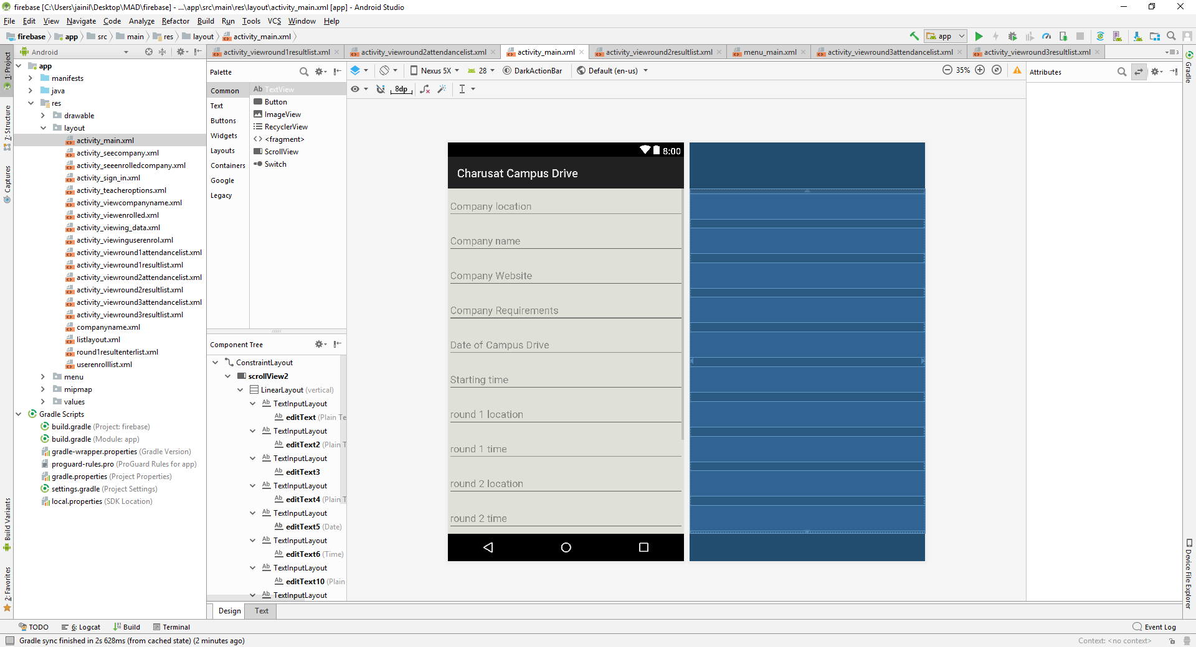

Figure 1android studio

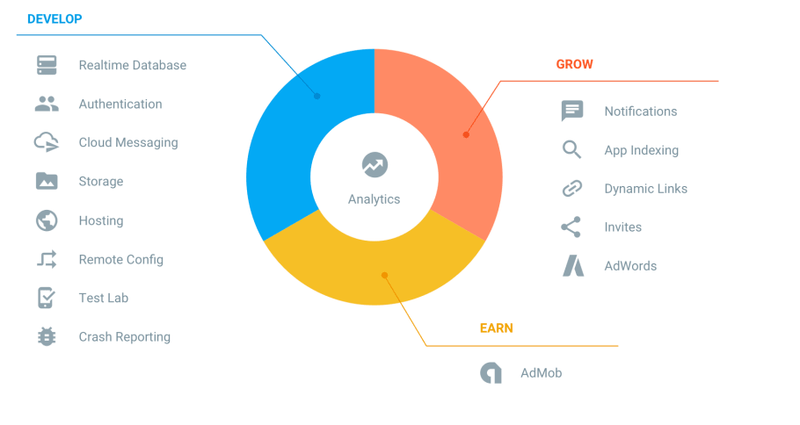

Figure 2:firebase features